11th March 2016

**YOKOHAMA impresses at Geneva Motor Show**

The Japanese Tyre manufacturer is having an impressive presence at the Geneva Motor Show this year.

In addition to launching two products as World premieres with the introduction of the ADVAN FLEVA V701, described to set the all new standard of High Performance, sporty tyre, and features which include extreme wet grip, amazing handling, low noise with a cool and attractive design. The second YOKOHAMA World premiere introduced was the ADVAN A052, as the ultimate street sporty tyre, with the most extreme grip ever. Also unveiled for the first time as a European premiere, was the GEOLANDAR A/T G015, which is a real All Terrain, On-Off Road tyre for 4x4 and SUVs developed to support the active vehicle lifestyle of drivers by delivering superior performance on any road surface under any weather condition. The use of an optimised tread pattern and new compound increases the tyre’s wear performance and traction performance on wet and snow-covered roads, hence displaying the snow flake marking.

During the launch, YOKOHAMA Europe President Keishi Hashimoto described the technical advances of the 3 new tyres and reviewed the past year of YOKOHAMA activity, highlighting the Chelsea Football Club partnership which was announced in 2015.

Representatives of YOKOHAMA in Europe and from Japan, made themselves available to meet and greet the media and explain the features and innovative technology in the new products.

On the second press day, YOKOHAMA invited Chelsea FC first team manager Guus Hiddink, to visit the YOKOHAMA booth and joined by Chelsea FC Managing Director, Christian Purslow explained some of his Global footballing experiences and how he has managed to improve the performance of Chelsea FC since he took over as interim manager. The “In conversation” session, brought together a panel made up of the two Chelsea FC representatives as well as YOKOHAMA Europe President Keishi Hashimoto and was moderated by YOKOHAMA Europe Communications Manager David Oliva. The session was very well attended by members of the International press, who also appreciated the interesting “relaxed conversation” with Guus Hiddink and members of the panel. After the special appearance, there was also an opportunity for photographs and the signing of autographs.

Special visitors to the YOKOHAMA booth at the Geneva Motor Show this year have also included Motorsports personalities such as World Touring Car Championship Drivers Norbert Michelisz and Rob Huff, both currently Honda Racing drivers, and Italian Legendary Rally Driver Marco Cavigioli, among others.

Also noteworthy at this edition of the Motor Show is the launch of the YOKOHAMA Europe app, now available in Europe. For more information on the app and the chance to win some exclusive YOKOHAMA prizes, including tickets for a Chelsea FC match or a new set of YOKOHAMA tyres please check:

[www.yokohama-online.com/app](http://www.yokohama-online.com/app)

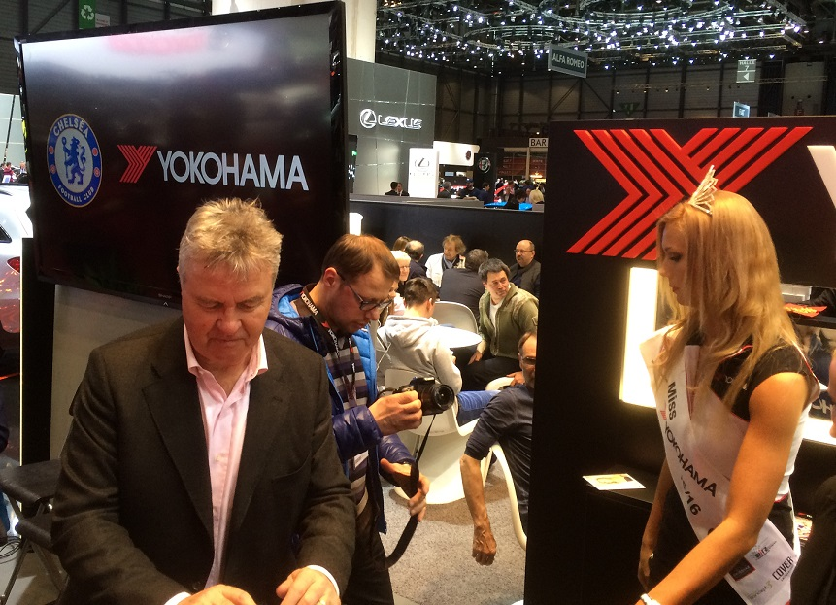

*Guus Hiddink signs autographs at YOKOHAMA booth*

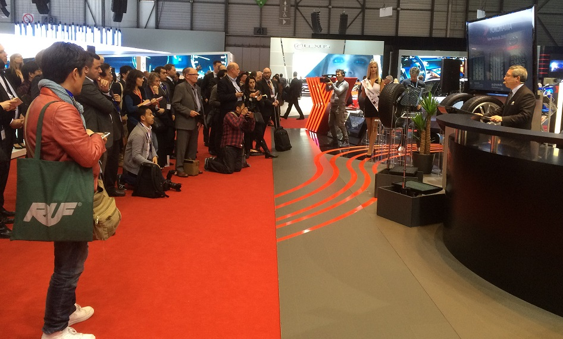

*YOKOHAMA Launches new tyres in World & European Premiere at Geneva*

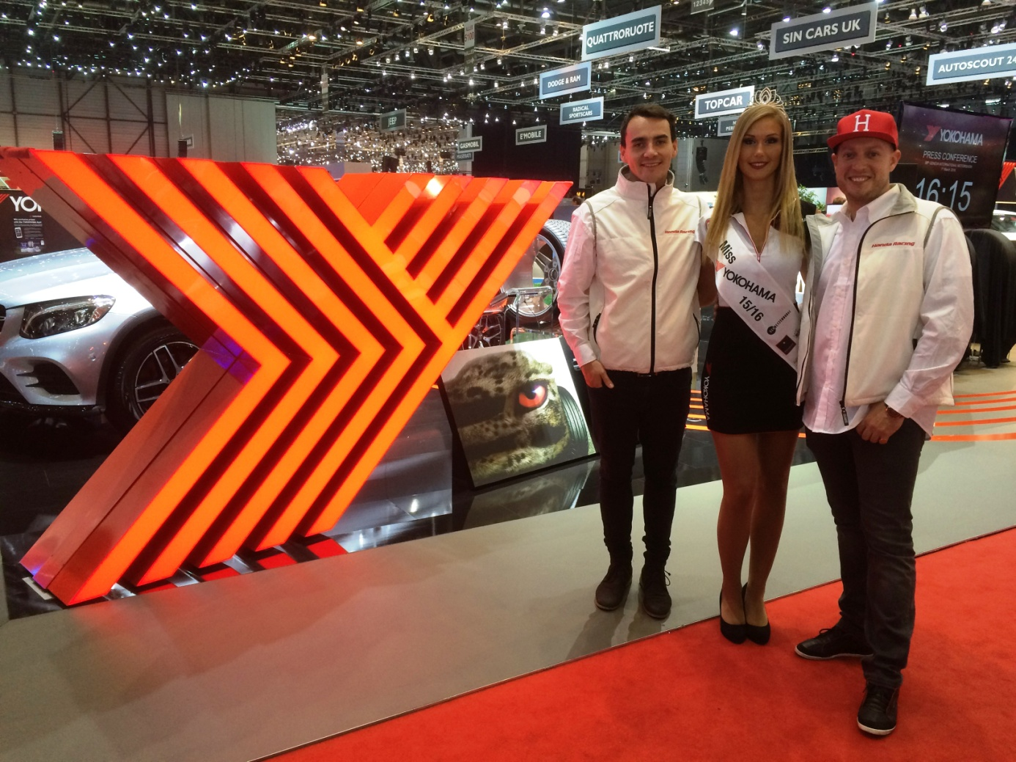

*Honda's WTCC Michelisz & Huff meet Miss YOKOHAMA at Geneva Motor Show*